Badminton Shuttle Feeder

# Servo für Feeder Greifer

<https://www.ebay.de/itm/2Power-HD-LW-20MG-20Kg-High-Torque-Digital-Servo-Mit-Metallgang-FuR-RC-Auto-O8A0/113181708512?hash=item1a5a27d0e0:g:6p8AAOSwCHBbA5lV&frcectupt=true>

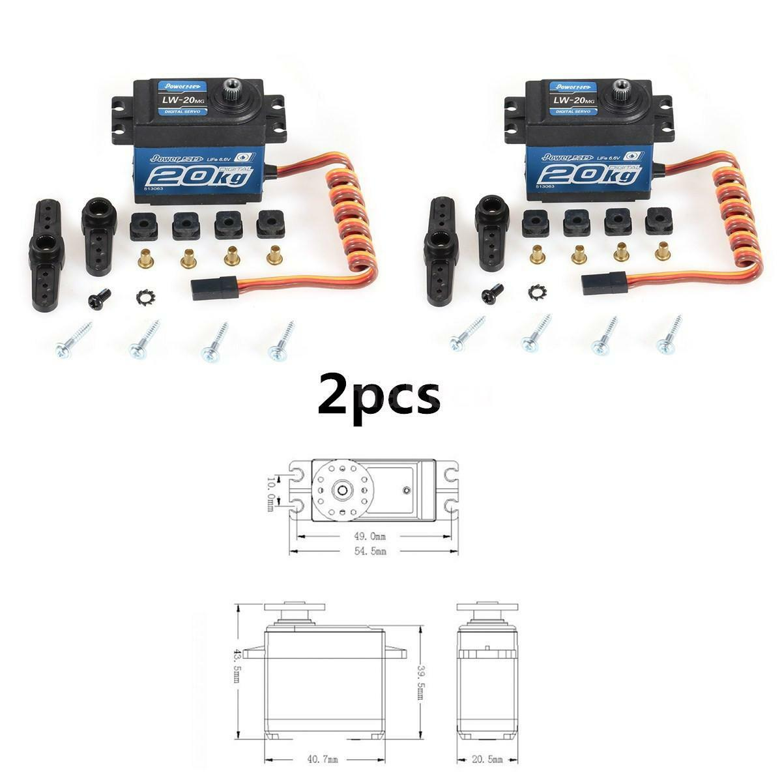

# Stepper Library

<https://github.com/laurb9/StepperDriver>

# Stepper Calculator

<https://www.prusaprinters.org/calculator/>

# Infos

https://www.youtube.com/watch?v=Gwg-Ge4gu9g